Table of content

1 Introduction 2

2 Background and terminology 2

2.1 Neural Networks 2

2.1.1 CNN 2

2.1.2 BNN 2

2.1.3 RNN 2

2.2 Hardware 2

2.2.1 FPGA 2

2.2.2 Google Coral dev board 2

2.2.3 Raspberry Pi 2

2.2.4 Summary of hardware specs 2

3 Method 3

3.1 Comparison 3

3.2 Models/networks used 3

3.3 Datasets 3

3.4 Implementation 3

4 References 4

# Introduction

Background, recent spike in interest, motivation, future possibilities, thesis outline

# Background and terminology

## From AI to NN

AI is a name for everything we consider to be intelligent and that can be implemented artificially.

Machine learning is the part of AI where the machine takes on the actual learning about the world around us and then puts that learning into good use.

Neural networks are one method for realizing Machine learning. Inspired by how the neurons and synapses in a brain functions, neural networks use the same general idea.

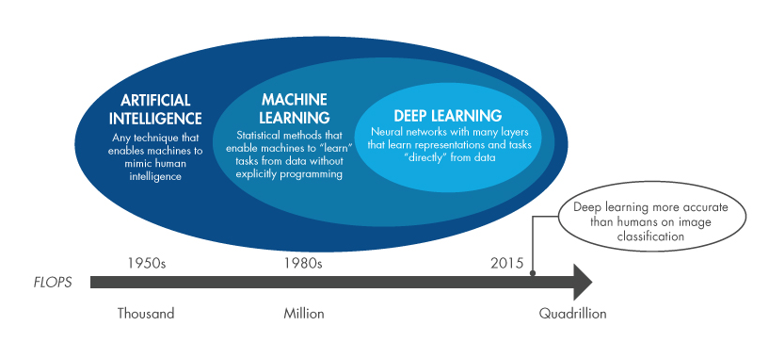

Figure 1. Från AI till Deep learning, en del av ML [1].

Gsdgsdg

dhdh

## Neural Networks

Neural networks [2]

Training vs classification/inference

Image classification vs object detection

Batching, what is it used for?

### CNN

Convolutional layer, pooling layer, FC layer, weights, activation function, eBNN.

### BNN

What makes a network binary, pros and cons, reference previous research

Xnor networks

Weight, bias

### RNN

How does it work and what is it used for?

## Hardware

### FPGA

History, uses, benefits for ML (parallelism, flexibility)

Construction (slices, LUTs, Flip-Flops, Block RAM)

Programming and implementation (HDL, Soft core CPUs)

Arty Z7-20 (Zynq 7000), CPU + FPGA – pros and cons – Software used (SDSoc, Vivado, ?)

### GPU

History, uses in general, ML uses

Construction, architecture

NVIDIA Jetson Nano – pros and cons, specs, software

### Google Coral dev board (maybe)

???

### Summary of hardware specs



Figure 2. Summary of hardware specs.

# Method

## Comparison

## Models/networks used

### AlexNet

### GoogLeNet

### VGG

### YOLOv3

## Datasets

## Implementation

# References

|  |  |
| --- | --- |
| [1] | The MathWorks, Inc, ”Deep Learning or Machine Learning,” The MathWorks, Inc, 18 09 2019. [Online]. Available: https://explore.mathworks.com/machine-learning-vs-deep-learning/chapter-1-129M-100NU.html. [Använd 18 09 2019]. |
| [2] | A. Shawahna, S. M. Sait och A. El-Maleh, ”FPGA-based Accelerators of Deep,” 01 01 2019. [Online]. Available: https://arxiv.org/pdf/1901.00121.pdf. [Använd 23 09 2019]. |
| [3] | B. McDanel, S. Teerapittayanon och H. Kung, ”Embedded Binarized Neural Networks,” i *International Conference on Embedded Wireless Systems and Networks*, Uppsala, 2017. |
| [4] | M. Courbariaux, I. Hubara, R. El-Yaniv och Y. Bengio, ”Binarized Neural Networks: Training Deep Neural Networks with Weights and Activations Constrained to +1 or -1,” 17 Mars 2016. [Online]. Available: https://arxiv.org/pdf/1602.02830.pdf. [Använd 13 09 2019]. |